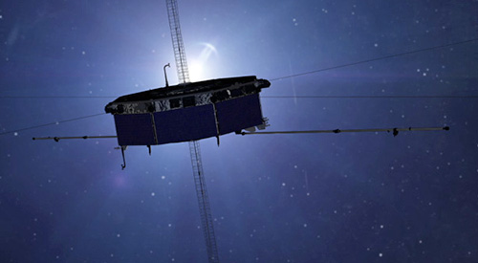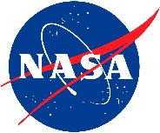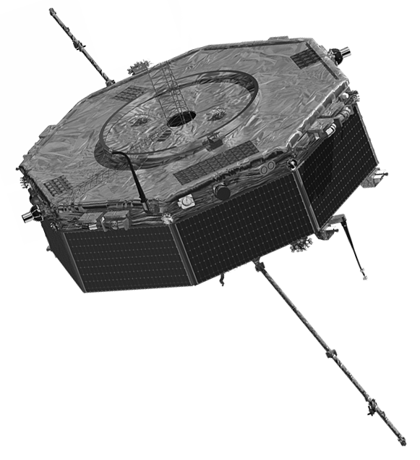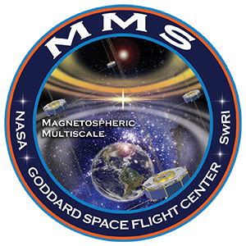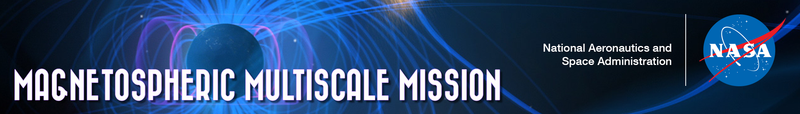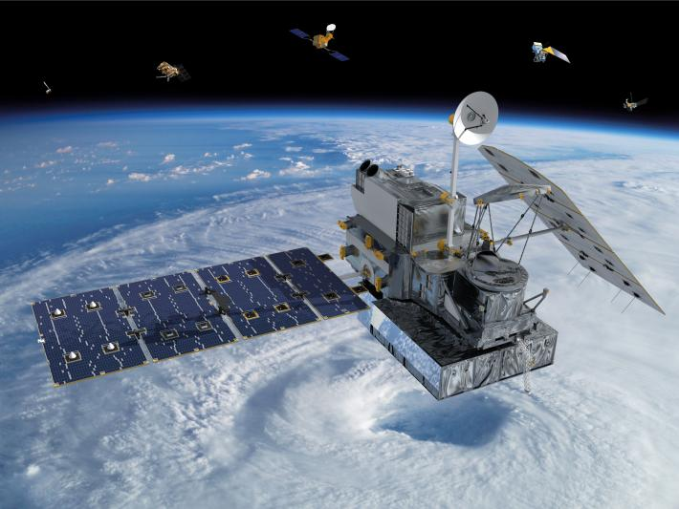

[Your date], 2015

[Time of Event] PM

Anytown Middle School

Magnetospheric Multiscale Mission Launch Party!

Celebrate the launch of NASA’s MMS mission and learn the mystery of how magnetic fields around Earth connect and disconnect, explosively releasing energy via a process known as magnetic reconnection. There will be hands-on activities, guest speakers, videos, and online discussions in our magnetic space café!

**SOMETOWN MIDDLE SCHOOL**

Science Department

www.schoolhomepage.org/sometown

mms.nasa.gov/education.html

**Watch the MMS Launch!**

**––––––––**

**Join the Online Discussion with MMS Magnetic Space Café!**

**––––––––**

**Watch MMS Videos!**

**––––––––**

**Invite Local Speakers!**

**––––––––**

**Provide MMS Handouts!**

**––––––––**

**Hands-On Activities!**

**http://mms.gsfc.nasa.gov/launch_kit/launch_party_kit.html • http://www.facebook.com/MagMultiScale • http://www.twitter.com/NASA_MMS**

**http://www.youtube.com/user/nasamms • http://www.flickr.com/groups/nasamms**

**SAMPLE – change to fit your event!**